PROJECT SYNOPSIS
ON
Fake News Detection on Elections Using Machine Learning

A report submitted in partial fulfillment of the requirements for award of the degree of Bachelor of Engineering in Computer Science and Engineering


Submitted by:
NAME: ARSHDEEP KOUR
ROLL NO: 04/20
UNIVERSITY ROLL NO: 201303003

Supervised by:
Ms. Kiranpal Kour (Asst. Professor)

DEPARTMENT OF COMPUTER SCIENCE AND ENGINEERING
M.B.S, COLLEGE OF ENGINEERING AND TECHNOLOGY
BABLIANA, JAMMU - 181101
March 2024

1

TABLE OF CONTENT

1. Title of the Project
2. Abstract
3. Introduction
4. Literature Survey
5. Problem Definition
6. Methodology
7. Objective
8. Proposed Outcome
9. Hardware Software Requirements
10. Conclusion

2

SYNOPSIS

TITLE OF THE PROJECT

Fake News Detection on Elections Using Machine Learning

3

ABSRACT:

In today’s world, fake news is a big problem, especially during important events like
elections. Our project is about finding and stopping fake news during the 2024 election.
utilizing a comprehensive approach that involves crafting a tailored dataset from trusted
fact-checking sources and social media sites like Instagram and Twitter. For example,
We’re using Instagram & tools to help us gather information quickly, X(Twitter) API and
web scraping like tools to achieve this.

Acknowledging the importance of precise and varied data, we are assembling our dataset
by sourcing information from trusted fact-checking sources like the Press Information
Bureau (PIB). Additionally, integrating data from prominent social media platforms such
as Instagram and @Twitter enhances the depth of our dataset, recognizing their significant
impact on public dialogue during electoral periods.

This approach not only allows us to efficiently collect relevant information but also
underscores our dedication to utilizing state-of-the-art technologies for thorough data
analysis.

Then, we’re proposing to use transformer-based models like DistilBERT etc., to analyze
this data. Our project combines technology, careful data collection, and smart analysis to
help fight fake news and make sure people have the right information for the 2024 election
and beyond.

4

INTRODUCTION:

In the contemporary era of information dissemination, the ubiquity of fake news has emerged as a formidable challenge, particularly during pivotal events such as elections. Fake news, characterized by the deliberate spread of misinformation or misleading content with the intent to deceive, has the potential to exert a profound impact on public opinion and the democratic process as a whole. As we stand on the cusp of the 2024 election, the need to address and mitigate the influence of fake news becomes increasingly urgent, demanding innovative approaches grounded in advanced technologies.

The focus of our project is on the detection of fake news during the upcoming 2024 election, employing a multi-faceted strategy that includes the creation of a bespoke dataset. Recognizing the critical role of accurate and diverse data, we are curating our own dataset, drawing information from reputable fact-checking sources such as the Press Information Bureau (PIB)*. The inclusion of data from social media giants, Instagram and @Twitter, further enriches our dataset, acknowledging the influential role these platforms play in shaping public discourse during elections.

To streamline the data acquisition process from #Instagram, we are utilizing its Application Programming Interface (API). This not only enables us to efficiently gather pertinent information but also underscores our commitment to leveraging cutting-edge technologies for comprehensive data analysis.

In the realm of data analysis, we are deploying advanced machine learning algorithms, with a specific emphasis on transformer-based models like Distil BERT. These models, known for their prowess in contextual understanding and semantic analysis, offer a sophisticated framework for discerning the subtle nuances inherent in fake news. The choice of Distil BERT reflects our dedication to employing state-of-the-art methodologies that balance computational efficiency with robust language comprehension.

5

Our project represents a synergistic convergence of technology, data curation, and analytical methodologies aimed at addressing the multifaceted challenges posed by fake news during the electoral process. By constructing and analyzing our dataset with cutting-edge tools, we aspire to contribute substantially to the ongoing discourse on combating misinformation, ensuring a more resilient and informed electorate during the crucial 2024 election and beyond.

6

Literature Survey

Fake news detection remains a critical challenge in today's information landscape, exacerbated by the ease of dissemination on web and social media platforms. Researchers have proposed various solutions to tackle this issue, yet many challenges persist due to the unstructured nature of available information. In a recent paper by Patil (2022), a majority voting approach is introduced for fake news detection, leveraging different textual properties of fake and real news articles. Utilizing a publicly available dataset comprising 20,800 news articles labelled as binary 0 and 1, the study evaluates the proposed approach using common machine learning classifiers such as Decision Tree, Logistic Regression, and SVM, among others. The results demonstrate the effectiveness of the majority voting technique, achieving an impressive accuracy of 96.38%, with precision, recall, and F1-measure all reaching 96%. This approach shows promise in enhancing fake news detection by combining the strengths of multiple classifiers. Other studies, such as Jain et al. (2019) and Janze & Risius (2017), also contribute to the field by presenting innovative models for fake news detection using machine learning and natural language processing techniques. These endeavor’s collectively advance the understanding and mitigation of fake news propagation, aiming to promote information authenticity and combat misinformation in the digital age.

7

Problem Definition

In the context of the 2024 Indian elections, the spread of fake news poses a significant
challenge that needs to be addressed. Fake news refers to false or misleading information
deliberately created and disseminated to deceive or manipulate people. During elections,
fake news can have serious consequences, including:
Misleading Voters: Fake news can mislead voters by presenting false information about
candidates, parties, or election-related issues, potentially influencing their voting decisions.
Undermining Democracy: When voters are influenced by fake news, the integrity of the
democratic process is compromised, as elections should be based on accurate information
and informed choices.
Creating Social Division: Fake news often exploits divisive issues, leading to polarization and
social unrest within the electorate. This can weaken the social fabric and undermine unity
within the country.
Erosion of Trust: Continuous exposure to fake news can erode public trust in media sources,
political institutions, and even the electoral process itself, leading to widespread skepticism
and disillusionment among voters.
Threat to Fair Elections: The proliferation of fake news can distort the electoral landscape,
potentially skewing election results and undermining the legitimacy of elected
representatives.

8
METHODOLOGY:

Logistic Regression: -Logistic regression is a supervised machine learning algorithm used for classification tasks where the goal is to predict the probability that an instance belongs to a given class or not. Logistic regression is a statistical algorithm which analyze the relationship between two data factors. The article explores the fundamentals of logistic regression, it’s types and implementations.

Random Forest:-Random Forest Regression in machine learning is an ensemble technique capable of performing both regression and classification tasks with the use of multiple decision trees and a technique called Bootstrap and Aggregation, commonly known as bagging. The basic idea behind this is to combine multiple decision trees in determining the final output rather than relying on individual decision trees.

Distil BERT: - Distil BERT, short for "Distill BERT," is a condensed version of the powerful BERT (Bidirectional Encoder Representations from Transformers) model, originally developed by Google for natural language processing (NLP). Crafted by researchers at Hugging Face, Distil BERT maintains BERT's contextual understanding of language by analyzing entire sentences instead of just individual words. The key objective behind DistilBERT is to preserve BERT's capabilities while streamlining its structure for improved efficiency.

Figure 1: Architecture of Distil BERT

SVM (Support Vector Machine):-A support vector machine (SVM) is a supervised machine learning model that uses classification algorithms for two-group classification problems. After giving an SVM model set of labelled training data for each category, they're able to categorize new text.

In our project, the initial phase involves the meticulous collection of data to construct a comprehensive dataset, leveraging information from fact-checking websites, Instagram, and Twitter. Subsequently, the collected data undergoes a rigorous cleaning process to eliminate inconsistencies and inaccuracies, ensuring the creation of a high-quality dataset. Following the data cleaning phase, we implement robust preprocessing techniques to further refine and organize the information. This meticulously curated and cleaned dataset serves as the foundation for training our model, employing advanced machine learning algorithms. The model's efficacy is then evaluated using a separate set of test data, enabling a comprehensive assessment of its predictive capabilities. As the model undergoes testing, it systematically generates predictions based on the learned patterns, contributing valuable insights to the broader context of fact-checking and information verification. This systematic approach ensures the development of a reliable and accurate model for discerning misinformation across diverse platforms



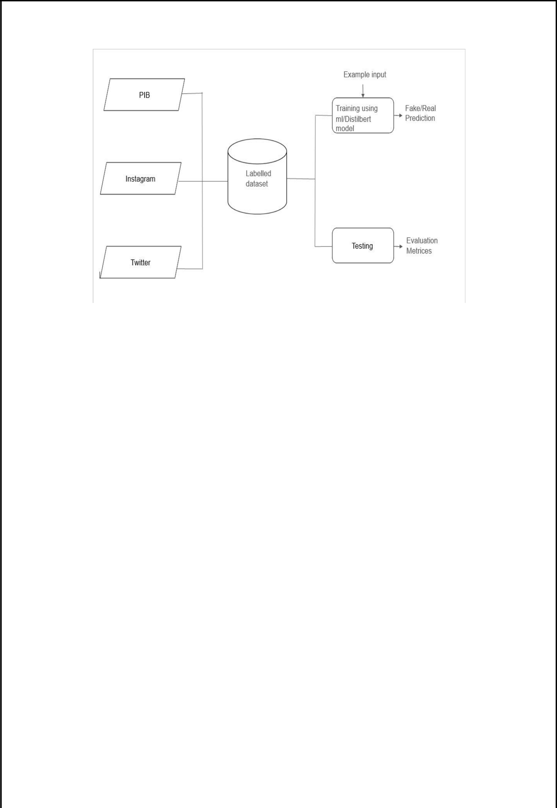

Figure 2: Proposed Methodology

DESCRIPTION

The methodology outlines the process of training and testing a machine learning model using labelled datasets from Pib, Instagram, and Twitter to predict fake and real news. It includes pre processing, feature extraction, model training, and evaluation with metrics like accuracy, precision, recall, and F1-score to assess performance.

10

Objective

The primary objective of this project is to develop robust techniques for the detection and
mitigation of fake news during the 2024 Indian elections. Specifically, the project aims to
achieve the following objectives:

Data Collection and Curation: Gather a comprehensive dataset comprising news articles,
social media posts, and other relevant sources to facilitate the training and validation of fake
news detection models.
Feature Engineering: Extract meaningful features from the collected data, including linguistic patterns, metadata, and contextual information, to enhance the accuracy and
Effectiveness of fake news detection algorithms.
Model Development: Employ state-of-the-art machine learning and natural language
processing techniques to develop predictive models capable of identifying fake news with
high precision and recall
Evaluation and Validation: Evaluate the performance of the developed models using rigorous testing methodologies, including cross-validation and real-world validation on unseen data, to assess their effectiveness in detecting fake news.
Deployment and Integration: Integrate the trained models into scalable and user-friendly
software tools or platforms that can be deployed for real-time monitoring and detection of
fake news during the 2024 Indian elections.

11

Problem outcome

Potential Problems from Fake News during the 2024 Indian Elections
During the 2024 Indian elections, fake news can cause some serious issues that we need to
tackle. Here are some of them:
1. Spreading Lies: Fake news can spread like wildfire, especially on social media. This
means people might believe things that aren’t true, which could mess up their voting
decisions.
2. Changing How People Think: Imagine if fake news tricks people into voting for someone
based on false information. It could really mess up the whole election and make people
doubt if its fair.
3. Making People Fight: Fake news often talks about touchy subjects, like religion or politics. If people believe it, it could make them argue or even fight with each other, dividing our society.
4. Losing Trust: If fake news keeps popping up, it could make people stop trusting the news
or the government. That’s not good for a healthy democracy where everyone should feel like
they can trust the information they get.
5. Threatening Democracy: When fake news messes with elections, it’s like playing with the heart of democracy. If people can’t trust what they hear and make decisions based on lies,
it’s hard to have a fair and honest elections.

HARDWARE AND SOFTWARE REQUIREMENTS:

• Platform Google Colab(GPU Support)
• M.L Library NumPy, Pandas, NLTK, Transformers
• Language Python 3.x
• Hardware Computer with Internet Access

CONCLUSION

In conclusion, our project proposing the pressing challenge of fake news during the 2024
election through a meticulous and innovative approach. By curating a bespoke dataset from
reputable fact-checking sources and social media platforms, we ensure a diverse and
reliable foundation for our analysis. Leveraging advanced technologies, including
Instagram’s API and transformer-based models like Distil BERT, we streamline data
acquisition and enhance language comprehension for effective fake news detection. Our
methodology incorporates diverse machine learning algorithms such as Logistic Regression,
Random Forest, DigitilBERT, and SVM, showcasing a comprehensive and sophisticated
analytical framework. The careful data cleaning and pre-processing stages underscore our
commitment to data quality and model robustness. Through this synergistic convergence of
technology and analytical methodologies, our project aims to contribute substantively to the
ongoing discourse on combating misinformation, fostering a more informed electorate
during the critical 2024 election and beyond.

